S3 backup terraform:



Terraform init:

Terraform validate:  


Terraform plan:

Terraform apply:

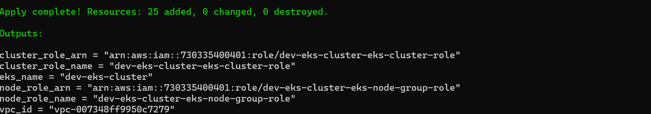

**Step 2**: **Install kubelet, kubeadm and kubectl**

* After the servers have been rebooted, add the Kubernetes repository for Ubuntu 20.04 to all of them

**sudo apt -y install curl apt-transport-httpscurl -s** [**https://packages.cloud.google.com/apt/doc/apt-key.gpg**](https://packages.cloud.google.com/apt/doc/apt-key.gpg) **| sudo apt-key add -echo “deb** [**https://apt.kubernetes.io/**](https://apt.kubernetes.io/) **kubernetes-xenial main” > sudo tee /etc/apt/sources.list.d/kubernetes.listORecho "deb https://apt.kubernetes.io/ kubernetes-xenial main" | sudo tee /etc/apt/sources.list.d/kubernetes.list**

* Then install the necessary packages

**sudo apt updatesudo apt -y install vim git curl wget kubelet kubeadm kubectlsudo apt-mark hold kubelet kubeadm kubectl**

* Check the version of kubectl to confirm the installation

**kubectl version --client && kubeadm version**

eks connected with ec2 for deployment:



